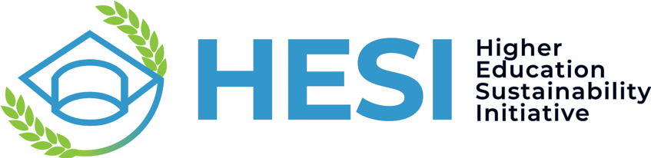
Enhancing Higher Education for Sustainable Development in Small Island Developing States
Side event to the Fourth International Conference on Small Island Developing States (SIDS4), organized by Higher Education Sustainability Initiative through UN DESA, UNITAR and UNESCO-IESALC
Thursday 30 May 2024, 08.00 – 09.30 AM, Room 3, Antigua and Barbuda
Concept note

Background
Small Island Developing States (SIDS) face unique challenges in their pursuit of sustainable development due to their geographical, economic, and environmental circumstances. Higher education institutions wield significant influence in shaping the trajectory of SIDS by educating leaders, conducting research, and fostering innovation in sustainability.
The Higher Education Sustainability Initiative (HESI) is a partnership involving various United Nations entities and the higher education community, aimed at integrating sustainability into education, research, and campus practices worldwide. Each year, HESI forms Action Groups to address pertinent issues concerning higher education for sustainable development. These groups leverage the expertise of the higher education community, often comprising multiple organizations and contributors.
Recognizing the crucial role of higher education in sustainable development within SIDS, this side event held alongside the Fourth International Conference on Small Island Developing States (SIDS4) is designed to enhance the contributions of higher education to sustainable development in SIDS over the coming decade.
The event will lay the groundwork for establishing a Higher Education for SIDS action network under HESI, building upon the groundwork by the University Consortium for SIDS. The focus areas of such Network could include:
- Enhancing collaborative research initiatives among higher education institutions in SIDS and international partners to address pressing challenges relevant to sustainable development, resilience, and the unique circumstances of SIDS.
- Fostering partnerships within higher education institutions in SIDS to promote internal collaboration across universities and external collaboration with various societal sectors.
- Strengthening the science-policy interface to support the implementation of the Antigua and Barbuda Agenda for SIDS (ABAS) and facilitating evidence-based policymaking processes in SIDS.
- Promoting teaching and curriculum development for sustainable development within SIDS, by aligning curricula with Sustainable Development Goals (SDGs), facilitating experiential learning, and offering capacity-building opportunities for educators.
- Providing capacity building to higher education institutions in SIDS through professional development opportunities, workshops, and training programs designed to enhance educators' competencies in teaching sustainability-related topics and innovative pedagogical approaches.
- Advocating for increased investments for higher education initiatives in SIDS and mobilizing resources to support sustainability projects in the region.
- Advocating for mobility through staff sharing and student exchanges among member institutions, enabling educators and students to gain international perspectives, develop cultural competencies, and engage in experiential learning related to sustainable development.

Programme
Time | Session
08.00 – 08.20 AM | Opening remarks  - UN DESA: Mr. Li Junhua, Under-Secretary-General for Economic and Social Affairs, UN DESA  - UNESCO IESALC: Mr. Vidar Helgesen, Executive Secretary and Assistance Director-General, Intergovernmental Oceanographic Commission, UNESCO
08.20 – 08.35 AM | Presentation – “The Higher Education for SIDS action network” – Mr. Sai Navoti, Chief, SIDS Unit, Division for SDGs, UN DESA
08.35 – 09.25 AM | Panel discussion - Higher Education for Sustainable Development in SIDS  Moderated by: Mr. Nikhil Seth, UNITAR Executive Director and UN Assistant Secretary-General  Panelists:  - Dr. Emily Wilkinson, Director, Resilient and Sustainable Islands  - Professor Mark Wuddivira from Caribbean Academy of Science, Dean of the Faculty of Food and Agriculture, The University of the West Indies, St. Augustine  - Mr. Kalim Shah, University of Delaware  - Ms. Naya Ifigenia Gomes Correia Sena, Peace Boat and University of Tokyo  Guiding questions  - What are the unique challenges faced by higher education institutions in SIDS when it comes to integrating sustainability into their programs, practices, academic programs, and research activities?  - How can partnerships between higher education institutions, governments, civil society, and other stakeholders be leveraged to support sustainable development in SIDS?  - How can universities in SIDS strengthen the science-policy interface to support the implementation of the Antigua and Barbuda Agenda for SIDS (ABAS), and what specific contributions can they make towards fostering this connection?
09.25 – 09.30 AM | Closing and next steps

The outcome of the SIDS4 interregional meeting, the 'Praia (Cabo Verde) Declaration', called for a revitalization of the University Consortium for SIDS. This revitalization is intended to tackle the distinct challenges and opportunities that SIDS face by consolidating expertise, research capabilities, and resources.

